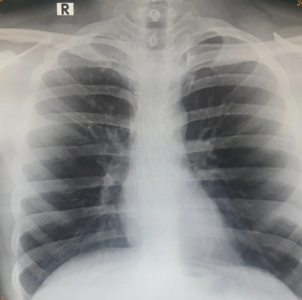
I still write but there's no poetry in these words.

I still make tracks but there's no music in that noise.

I still capture things - but I've lost my perspective.

heck I took an X-ray cause I couldn't breathe. Yet was more delighted to find I still had what looked like a heart.

It is still difficult to breathe, I don't know why.

One day fades into another-and into another -and into another

I've realised that we end up living most our lives looking back at a few things, and looking forward to others, as the present keeps passing us by.

I guess adulting is about making peace with it.

The fact that you can never live in the present.

Unless our past has given us that freedom- and future-that assurance.

We're bad with too much, or too little of either those things.

and so the cycle continues.

There is no poetry.

Only people.

There is no present.

Only an ever distant past and a fleeting future.

The day I'll relearn tying all of them together to form a picture which says to me that maybe none of it had to make sense in the first place- would be the day the poetry would revive itself.

Till then- all I have are words, all you'll have- will be words- trying to conceptualize, categorize and assign meaning to things-

Worthy to some, worthless to others.

But there shall be no poetry.

